Weekly News

14th June 2019
Important information  for those children moving into the Reception class at Crackley Hall School, here in September…  Tuesday 25th June: 6-7pm  Parents  Meet Mrs Glen-Roots, our Assistant Head responsible for Early Years and KS1, to receive your starter pack with information for next year.  Wednesday 26th June  Children  Induction Morning  Come in and spend the morning in your new Reception class! | PRE-SCHOOL GRADUATION!!!  Tuesday 25th June 2pm  unfortunately just 2 adults per child  thank you  School closes for the Summer  (term time children)  Wednesday 3rd July
Recipe of the week
Ingredients  - 1 cup frozen mango chunks  - 1 cup frozen strawberries  - 1 cup ice  - 1 frozen banana, sliced  - 1/2 cup milk  - 1/2 cup water  - 1/4 cup orange juice  - 1/4 cup plain Greek yogurt  - 1 teaspoon honey | Tropical Fruit Smoothie  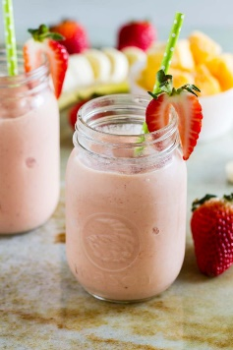  Method:  Blend until smooth!!! | - 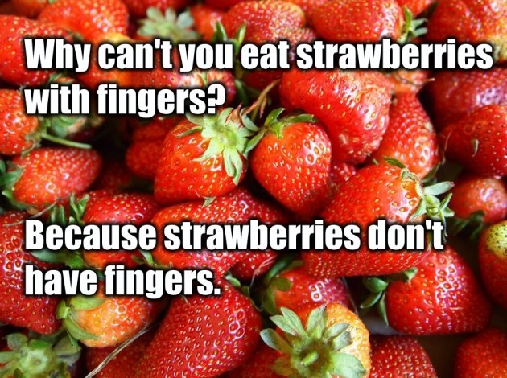

Little Crackers Nursery · Crackley Hall · St Joseph’s Park · Kenilworth · CV8 2FT
Telephone: 01926 514444 · Fax: 01926 514455 · e-mail: littlecrackers@crackleyhall.co.uk
www.crackleyhall.co.uk

Registered Charity Number 1087124 Company limited by guarantee Number 4177718

You can email Mrs Bird clarebird@crackleyhall.co.uk
or ring the nursery direct 01926 514456

